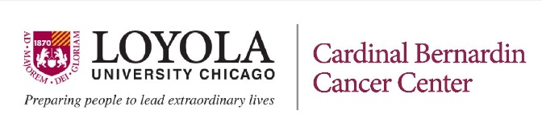
2025 Summer Student Oncology Research Internships
sponsored by the Department of Cancer Biology and
the Cardinal Bernardin Cancer Center

Loyola University Chicago’s Department of Cancer Biology and the Cardinal Bernardin Cancer Center are sponsoring ten-week full-time research internships this summer at the Cancer Center (Health Sciences Campus in Maywood) for LUC students. All LUC Freshman, Sophomore, and Juniors with an interest in cancer research are eligible to apply; students who will graduate in May or December of 2025 are not eligible. A brief recommendation from a faculty member in the student’s major department must be submitted in addition to the student’s application.

Opportunities are available across various areas; applicants must select a research program of interest:

- Cancer Biology and Therapeutics Program - Research groups who participate in this program study mechanisms associated with cancer cell initiation and disease progression, mechanisms that contribute to therapeutic responses, and mechanisms that account for therapeutic resistance. A wide variety of approaches and model systems are used to advance understanding in multiple different cancer types. The ultimate goal is to utilize the knowledge gained to improve therapeutic efficacy and cancer patient outcomes. Students who participate in this program will be engaged in “wet” lab research and will learn techniques for culturing live human cells, including malignant cancer cells.

- Radiation Oncology, Imaging, and Technology Program - This program brings together radiation oncologists, radiologists, physicists, imaging scientists, engineers, computer scientists and radiation biologists to foster research that integrates clinical, basic science and engineering approaches. The goal: to improve tumor control with radiation, while minimizing side effects, and develop novel imaging approaches for localized and disseminated disease. Students who participate in this program will perform research that will involve computer programming and may also include image processing, machine learning, or analysis of radiation dose distributions.

Applications will undergo a competitive review process. Student interns accepted into the program will receive supervised experiences in cancer research projects currently in progress in laboratories in the Cancer Center or the Radiation Oncology Dept., both of which are located on the Health Sciences campus in Maywood, Illinois. Interns are expected to commit to full time work for the entire 10-week program. A stipend will be awarded to each student intern who is accepted for this competitive summer program.

KEY DATES: Internship Application and Program Timeline:

- Application due date: Friday, February 28, 2025
- Review period: March 3 – 22, 2025
- Internship award letters / invitations sent: April 1, 2025
- Commitments needed from students: April 12, 2025
- Internship start/end date: May 19 – July 25, 2025 (ten weeks)
- Summer interns symposium: Monday, July 28, 2025

Contact Fr. Breslin, S.J. with any questions (office QLSB 442; email: pbresli@luc.edu)

Submit your application via InfoReady

